Name:Saniya goutam
5th sem prn: 23070521126
Prac 6-10
PRAC 6

DNS Packet Analysis (Windows only)

Analysis of Application Layer Packets (DNS) using DNS commands & Wireshark in Windows

Objective:
- To understand the working of DNS as an application layer protocol.
- To analyze DNS packets generated by DNS commands.
- To capture and study DNS packets using Wireshark on Windows.

Software/Tools Required:
- Windows PC with Internet access
- Command Prompt (cmd)
- Wireshark (download from https://www.wireshark.org/)

Step-by-step Procedure:

Part A: Using DNS Commands (nslookup)

Step 1: Open Command Prompt
- Press Win + R, type cmd, and press Enter.

Step 2: Find IP address of a domain
nslookup www.example.com
- Observe:
  - DNS server used (often your ISP’s DNS or local DNS server)
  - The resolved IP address

Step 3: Perform a reverse lookup (IP → domain)
nslookup 93.184.216.34
- See the canonical domain name corresponding to the IP.

Step 4: Query different DNS record types (e.g., mail servers)
nslookup -query=MX example.com
- Shows mail exchange servers for the domain.

Part B: DNS Packet Analysis with Wireshark

Step 1: Install and open Wireshark
- Download and install Wireshark.
- Open Wireshark as Administrator.

Step 2: Start capturing packets
- In the Wireshark main window, select your active interface (usually Wi-Fi or Ethernet).
- Click the blue shark fin icon to start capture.

Step 3: Generate DNS traffic
- In Command Prompt, run:
nslookup www.example.com

Step 4: Stop capturing
- Click the red square (Stop) in Wireshark.

Step 5: Filter DNS packets
- In the filter bar at the top of Wireshark, type:
dns
- Press Enter to filter and display only DNS-related packets.

Step 6: Analyze captured packets
- Select the DNS query packet (from your PC to DNS server, usually UDP port 53).
- Expand:
  - Transaction ID: used to match request & response
  - Flags: standard query, recursion desired, response
  - Questions: the domain name queried
- Select the response packet from DNS server:
  - Observe the resolved IP address under the Answers section.

Observation Table
Step | Command / Action | Observation
1 | nslookup www.example.com | Resolved IP address shown
2 | nslookup -query=MX example.com | Mail server records shown
3 | Wireshark capture | DNS query and response packets
4 | Packet details | Transaction ID, flags, domain name, IP address

Result:
- Successfully generated DNS requests using nslookup.
- Captured and analyzed DNS packets using Wireshark on Windows.

Conclusion:
- DNS translates domain names to IP addresses.
- Using Wireshark on Windows helps visualize real DNS query-response exchanges.

PRAC7

Lab Practical: Application Layer Packet Analysis using Packet Tracer Tool

Aim:
To analyze Application Layer packets (DNS & HTTP) using a packet tracer tool (Wireshark) and understand their structure and working.

Tools Required:
- Wireshark (Packet Analyzer)
- Internet Connection or Local DNS/HTTP Server
- Browser or Command Line Tools (nslookup, ping)

Procedure:

Part A: DNS Packet Analysis
- Start Wireshark and begin packet capture on the active network interface (WiFi/Ethernet).
- Open Command Prompt or Terminal and type:
- nslookup www.google.com
- In Wireshark, stop the capture after response.
- Apply filter:
- dns
- Select the DNS query and observe the following:
  - Transaction ID
  - Flags: Query/Response
  - Query Name: e.g., www.google.com
  - Query Type: A (IPv4)
- Click on the DNS Response packet and observe:
  - Resolved IP Address
  - TTL (Time to Live)
  - Answer Section

Part B: HTTP Packet Analysis
- In the browser, type:
- http://example.com
- In Wireshark, apply filter:
- http
- Observe the HTTP GET request:
  - Method: GET
  - Host: example.com
  - User-Agent
- Observe the HTTP Response:
  - Status Code: 200 OK
  - Content-Type: text/html
  - Content-Length

Observations:
Field | DNS Query | DNS Response | HTTP Request | HTTP Response
Protocol | UDP | UDP | TCP | TCP
Port | 53 | 53 | 80 | 80
Method/Type | Standard Query (A Record) | Response | GET / | 200 OK
IP Address Queried | www.google.com | e.g., 142.250.77.68 | example.com | IP of example.com
TTL | - | 300 seconds (example) | - | -
Content-Type | - | - | - | text/html

Result:
Successfully analyzed DNS and HTTP packets using Wireshark. The structure and fields of Application Layer packets were observed and interpreted.

Conclusion:
- DNS resolves domain names to IP addresses via UDP port 53.
- HTTP works over TCP port 80, where the client sends a GET request and receives a response with status and content.
- Wireshark effectively captures and visualizes Application Layer communication for analysis and troubleshooting.

PRAC 8
the Sliding Window Protocol (Go-Back-N variant)
This example includes:
Sender side
Receiver side (simulated)
Uses arrays and simple logic to simulate sending, acknowledgment, and sliding of window.

Algorithm: Sliding Window Protocol (Go-Back-N ARQ)
Input:
- Total number of frames to send N
- Window size W

Steps:
- Initialize:
  - Set base = 0 (first frame in window)
  - Set next_seq_num = 0 (next frame to send)
- While base < N:
  - While next_seq_num < base + W and next_seq_num < N:
    - Send frame with sequence number next_seq_num
    - Increment next_seq_num = next_seq_num + 1
- Wait for acknowledgment:
  - If ACK is received for frame base:
    - Increment base = base + 1
  - Else (timeout or error detected):
    - Retransmit all frames from base up to next_seq_num - 1
- Repeat until all frames are sent and acknowledged (base >= N)
- End

Explanation:
- The sender can send up to W unacknowledged frames.
- If an error or timeout occurs for a frame, the sender goes back and retransmits from that frame onward.
- Receiver keeps track of the expected sequence number and discards out-of-order frames.

Additional (Receiver side):
- Initialize expected_seq_num = 0
- When a frame with sequence number seq_num arrives:
  - If seq_num == expected_seq_num:
    - Accept the frame
    - Deliver it to higher layer
    - Send ACK for expected_seq_num
    - Increment expected_seq_num
  - Else:
    - Discard frame
    - Resend ACK for expected_seq_num - 1

Summary:
- Go-Back-N allows the sender to transmit multiple frames before waiting for ACKs.
- Upon error, retransmission starts from the frame where the error occurred.
- Efficient for networks with fewer errors and longer delays.

C Program: Sliding Window Protocol (Go-Back-N)
#include <stdio.h>
#include <stdlib.h>
#include <time.h>

#define MAX_FRAMES 50

void sender(int frames[], int size, int window_size);
void receiver(int frames[], int start, int window_size);

int main() {
int n, window_size;
int frames[MAX_FRAMES];

printf("Sliding Window Protocol Simulation (Go-Back-N)\n");
printf("Enter number of frames to send (max %d): ", MAX_FRAMES);
scanf("%d", &n);

if(n > MAX_FRAMES || n <= 0) {
printf("Invalid number of frames.\n");
return 0;
}

printf("Enter window size: ");
scanf("%d", &window_size);

if(window_size <= 0 || window_size > n) {
printf("Invalid window size.\n");
return 0;
}

// Fill frames with sequence numbers
for(int i=0; i<n; i++) {
frames[i] = i;
}

sender(frames, n, window_size);

return 0;
}

void sender(int frames[], int size, int window_size) {
int base = 0;
int next_seq = 0;
char choice;

srand(time(NULL));

while(base < size) {
printf("\nSender window: ");
for(int i=base; i<base+window_size && i<size; i++) {
printf("[%d] ", frames[i]);
}
printf("\nSending frames...\n");

for(int i=base; i<base+window_size && i<size; i++) {
printf("Sent frame: %d\n", frames[i]);
}

printf("\nSimulating receiver...\n");
receiver(frames, base, window_size);

printf("\nDid all frames receive correctly? (y/n): ");
scanf(" %c", &choice);

if(choice == 'y' || choice == 'Y') {
base += window_size;
} else {
printf("Resending from frame %d...\n", frames[base]);
// In Go-Back-N, we resend from base
}
}

printf("\nAll frames sent successfully!\n");
}

void receiver(int frames[], int start, int window_size) {
for(int i=start; i<start+window_size; i++) {
printf("Received frame: %d, sending ACK: %d\n", frames[i], frames[i]+1);
}
}

How it works:
- The sender keeps track of a base and a window_size.
- It sends frames within [base, base+window_size).
- After sending, it asks the user if all frames were received correctly.
- If yes, it slides the window forward by window_size.
- If not, it resends starting from base.

How to run:
- Save as sliding_window.c.
- Compile:
gcc sliding_window.c -o sliding_window
- Run:
./sliding_window

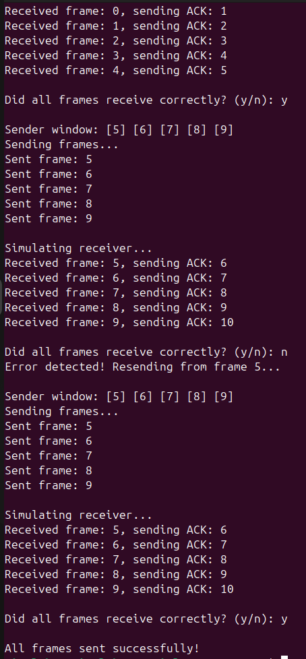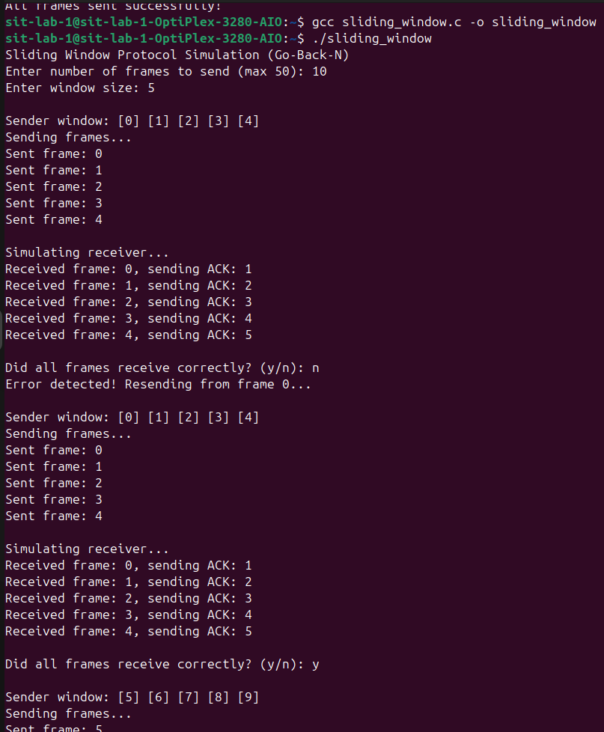
PRACTICAL 9
Traffic Shaping algorithms in C – the two classic ones are:
✅ Leaky Bucket algorithm
✅ Token Bucket algorithm
- Algorithm: Leaky Bucket
Input:
- Bucket capacity B
- Outgoing rate R
- Number of time units N
- Number of incoming packets in each time unit P[i]

Algorithm steps:
- Initialize:
  - Set stored = 0 // number of packets currently in bucket
- For each time unit i from 1 to N:
a. Read number of incoming packets P[i]
b. Check if stored + P[i] > B
  - If yes:
    - Packet overflow = stored + P[i] - B
    - Drop the overflow packets
    - Set stored = B
  - Else:
    - stored = stored + P[i]
c. If stored <= R:
  - Send all packets (stored)
  - stored = 0
d. Else:
  - Send R packets
  - stored = stored - R
e. Print number of packets sent and packets left in bucket
- After all time units:
  - While stored > 0:
    - If stored <= R:
      - Send all remaining packets
      - stored = 0
    - Else:
      - Send R packets
      - stored = stored - R
- End

Summary:
- Fixed output rate R
- Excess incoming packets beyond capacity B are dropped
- Smoothens bursty input to fixed output rate

Leaky Bucket Algorithm (C Program)
This simulates a fixed-rate outflow of packets, buffering bursty input.
#include <stdio.h>

int main() {
int bucket_size, n, i, incoming, outgoing, stored = 0;

printf("Leaky Bucket Algorithm Simulation\n");
printf("Enter bucket size (capacity): ");
scanf("%d", &bucket_size);
printf("Enter outgoing rate: ");
scanf("%d", &outgoing);
printf("Enter number of packets (time units): ");
scanf("%d", &n);

for(i=0; i<n; i++) {
printf("\nTime unit %d:\n", i+1);
printf("Enter number of incoming packets: ");
scanf("%d", &incoming);

if(incoming + stored > bucket_size) {
printf("Bucket overflow! Packet loss = %d\n", incoming + stored - bucket_size);
stored = bucket_size;
} else {
stored += incoming;
}

if(stored <= outgoing) {
printf("Packets sent: %d\n", stored);
stored = 0;
} else {
printf("Packets sent: %d\n", outgoing);
stored -= outgoing;
}

printf("Packets remaining in bucket: %d\n", stored);
}

// Drain remaining packets
while(stored > 0) {
printf("\nDraining remaining packets...\n");
if(stored <= outgoing) {
printf("Packets sent: %d\n", stored);
stored = 0;
} else {
printf("Packets sent: %d\n", outgoing);
stored -= outgoing;
}
printf("Packets left in bucket: %d\n", stored);
}

printf("\nSimulation complete.\n");
return 0;
}
- Algorithm: Token Bucket
Input:
- Bucket capacity B (max tokens)
- Token generation rate R (tokens added per time unit)
- Number of time units N
- Number of packets to send in each time unit P[i]

Algorithm steps:
- Initialize:
  - Set tokens = 0 // current number of tokens
- For each time unit i from 1 to N:
a. Add R tokens: tokens = tokens + R
b. If tokens > B:
  - tokens = B
c. Read number of packets to send P[i]
d. If tokens >= P[i]:
  - Send P[i] packets
  - tokens = tokens - P[i]
e. Else:
  - Send tokens packets
  - Packets dropped = P[i] - tokens
  - tokens = 0
f. Print packets sent, tokens left, and packets dropped
- End

Summary:
- Allows bursty traffic if enough tokens are available
- Tokens accumulate up to capacity B
- Packets sent depend on available tokens; excess packets are dropped

Token Bucket Algorithm (C Program)
This allows burstiness controlled by tokens.
#include <stdio.h>

int main() {
int bucket_size, n, rate, tokens = 0, incoming, i;

printf("Token Bucket Algorithm Simulation\n");
printf("Enter bucket size (capacity): ");
scanf("%d", &bucket_size);
printf("Enter token generation rate: ");
scanf("%d", &rate);
printf("Enter number of packets (time units): ");
scanf("%d", &n);

for(i=0; i<n; i++) {
printf("\nTime unit %d:\n", i+1);

tokens += rate;
if(tokens > bucket_size) tokens = bucket_size;

printf("Enter number of packets to send: ");
scanf("%d", &incoming);

if(tokens >= incoming) {
printf("Packets sent: %d\n", incoming);
tokens -= incoming;
} else {
printf("Only %d tokens available, packets sent: %d, packets dropped: %d\n",
tokens, tokens, incoming - tokens);
tokens = 0;
}

printf("Tokens left: %d\n", tokens);
}

printf("\nSimulation complete.\n");
return 0;
}
To compile & run (same for both):
gcc leaky_bucket.c -o leaky
./leaky
or
gcc token_bucket.c -o token
./token

Explanation (for your lab manual):
- Leaky bucket keeps fixed outflow, dropping excess.
- Token bucket allows bursts as long as tokens are available.

Distance Vector Routing Algorithm in C — often used in network simulations to demonstrate how routers share distance vectors to calculate the shortest paths. 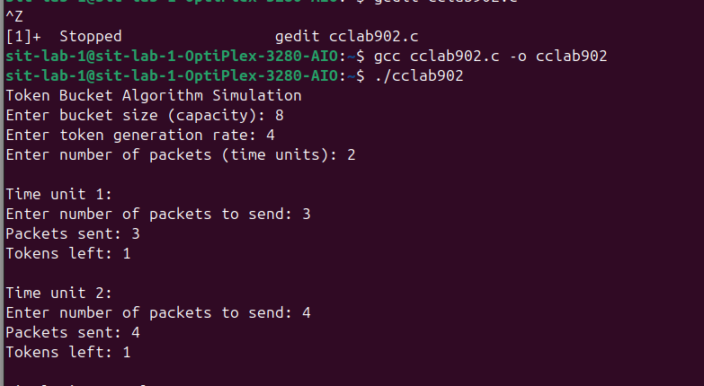
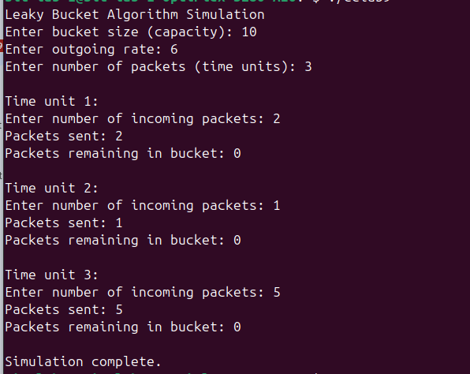

PRAC 10

Distance Vector Routing Algorithm in C

Algorithm: Distance Vector Routing
Input:
- Number of nodes in the network, N
- Cost matrix C[N][N] where C[i][j] is the cost to go from node i to node j

Steps:
- For each node i (1 ≤ i ≤ N):
  - Initialize its distance vector DV[i]:
    - DV[i][j] = C[i][j] for all j
  - Set the next hop to j if there is a direct connection; otherwise, to -1
- Repeat the following steps until no distance vector changes:
  - For each node i:
    - For each destination node j:
      - For each neighbor k of node i:
        - If DV[i][j] > C[i][k] + DV[k][j]:
          - Update DV[i][j] = C[i][k] + DV[k][j]
          - Set next hop to k
- After convergence, print the final distance vectors (routing tables) for all nodes

Explanation:
- Each node exchanges its distance vector with its immediate neighbors.
- On receiving a neighbor’s vector, it updates its own vector if it finds a shorter path.
- This repeats until no update is needed (network converges).

C program
#include <stdio.h>

#define MAX_NODES 10
#define INF 9999

struct Node {
int dist[MAX_NODES];
int from[MAX_NODES];
} rt[MAX_NODES];

int main() {
int cost[MAX_NODES][MAX_NODES], nodes, i, j, k, updated;

printf("Enter number of nodes: ");
scanf("%d", &nodes);

printf("Enter cost matrix (use 999 for ∞/no connection):\n");
for (i = 0; i < nodes; i++) {
for (j = 0; j < nodes; j++) {
scanf("%d", &cost[i][j]);
cost[i][i] = 0;
rt[i].dist[j] = cost[i][j];
rt[i].from[j] = j;
}
}

do {
updated = 0;
for (i = 0; i < nodes; i++) {
for (j = 0; j < nodes; j++) {
for (k = 0; k < nodes; k++) {
if (rt[i].dist[j] > cost[i][k] + rt[k].dist[j]) {
rt[i].dist[j] = cost[i][k] + rt[k].dist[j];
rt[i].from[j] = k;
updated = 1;
}
}
}
}
} while (updated);

// Display routing table
for (i = 0; i < nodes; i++) {
printf("\nRouting table for Node %d:\n", i);
printf("Destination\tNext Hop\tDistance\n");
for (j = 0; j < nodes; j++) {
printf("%d\t\t%d\t\t%d\n", j, rt[i].from[j], rt[i].dist[j]);
}
}

return 0;
}

Sample Input
Enter number of nodes: 3
Enter cost matrix:
0 2 7
2 0 1
7 1 0

Compile and Run
gcc distance_vector.c -o dv
./dv

Explanation
- Each router (node) maintains a table with:
  - Distance to every other node
  - Next hop to reach each node
The algorithm loops until no updates are made, ensuring the shortest paths are computed. 